Plant a Tree
Help the Land of Israel Grow

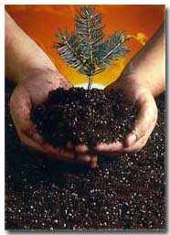
THE SISTERHOOD AT TEMPLE SHAARAY TEFILA
is proud to offer this program to our Congregants
to celebrate a simcha or to commemorate a loss.

To date, we have sold thousands of trees and we look forward to continuing our support of Israel’s future.

*Tree Order Form*
$18. FOR Each tree
total # of trees_______ $_______ enclosed

Please make check payable to: Temple Shaaray Tefila Sisterhood
89 Baldwin Road
Bedford Corners, NY 10549
ATTN: SISTERHOOD

DATE___________

DONOR INFORMATION (PLANTED BY):

Name ________________________________________________
Phone ____________________ e-mail ____________________

IN MEMORY OF / IN HONOR OF :___________________________
Message(if desired)___________________________________

Send Certificate to:

NAME ______________________________________________
Address ___________________________________________
City ________________________________________________
State ____________________ Zip ___________________

*All B’naiMitzvah Children receive a tree From
Temple Sisterhood to commemorate their special event!

*Sisterhood supports Caring Community Tree Donations!

contact: lynn federbush: LYNNFEDERBUSH@GMAIL.COM

